Knowledge Document
APSTSI
Application Type | - Business Critical (Tier2)

Mayank Kaushik

[This document contains proprietary information of HCL Technologies Ltd. and the filled in information would be for the exclusive use of designated ExxonMobil and HCL only. No part of this document may be reproduced, stored, copied, or transmitted in any form or by means of electronic, mechanical, photocopying or otherwise, without the express consent of ExxonMobil and/or HCL Technologies Ltd.]

Revision History
Version No. | Date | Prepared/Modified by | Significant Changes
1.0 | 05/31/2021 | Gaurav Gupta  Dharmendra Singh  Kaushik Kumar  Rizwana Kowsar | First Version
2.0 | 09/16/2021 | Mayank Kaushik | Second Version

Glossary
Abbreviation | Description
STSI | SAP/TAS System Interface
APSTSI | Asia Pacific STSI
TAS | Terminal Automation System
CS | Customer Service
PMI | Product Management Inventory
BOL | Bill of Lading
APSDL | AP Standard Data Load
APBPT | AP Box Product Transaction Transfer
APIMT | AP Interface Monitoring Tool
APAUS | AP Australia
APNZ | AP New Zealand
APTHAI | AP Thailand
APHK | AP Hong Kong
APVEH | AP Vehicle Interface
APMSG | AP Message
TAS | Terminal Automation System
BCP | Bulk Copy Protocol
RCP | Rate Control Protocol
FTPS | File Transfer Protocol Secure

INTRODUCTION
  - Purpose of Document
This document provides the functional and technical overview of APSTSI along with operational information that would be required to support the application on a day to day basis. Objective for preparing this document is to capture comprehensive knowledge about APSTSI in single place. Thus, reducing effort of readers to refer multiple documents
  - Scope of Document
This document covers the following for APSTSI ─
- Functional overview
- Technical overview
- Operational/Support information
  - Audience

This document could be referred by following ─
- Project Manager
- Business Analyst
- Developers
- Testers
- Support Personnel

APPLICATION FUNCTIONAL OVERVIEW

  - Application Functionality

STSI is an in-house built application used to convert, extend validate, reprocess data regarding fuel loading/transfer of Trucks, barges, vessels, Railcar, Pipeline system etc. It is a (High Risk- Critical) interface and middleware between multiple SAP systems and the terminal loading system.
STSI receive data from various SAP and third party applications STSI perform the various activities using automation engine (UC4) on the data and then the data would be send to TAS system. We have predefined multiple UC4 jobs those are responsible to perform the country specific logic by calling a stored procedures and insert, Update operations.
Inside APSTSI Programs:
- APSTSI is a 2 tier server, where Application and Database are kept on the same server. And we send the information to the client when they using their web browser and connect it to our APSTSI Application
  - Frontend Program is using .Net (Contain only for view function to our web application)
  - Backend Program is using SQL Server (Contains all Business Logic, Data Validation and Data Translation- that can be useful for translating data between SAP and TAS system)
  - APSTSI Application depends on various programming language to handle various scenarios:
    - Bash Programming for OF08 for Data Processing and File Management
    - VB6 Programs for getting data into Database by using BCP (Bulk Copy Protocol) and triggering stored procedure to run by UC4
    - DTSX in order to get data into the database by using only for Message set 12,13
  - App related data available in F drive.
  - SQL related data available in G drive

APSTSI environment:
• Production Server 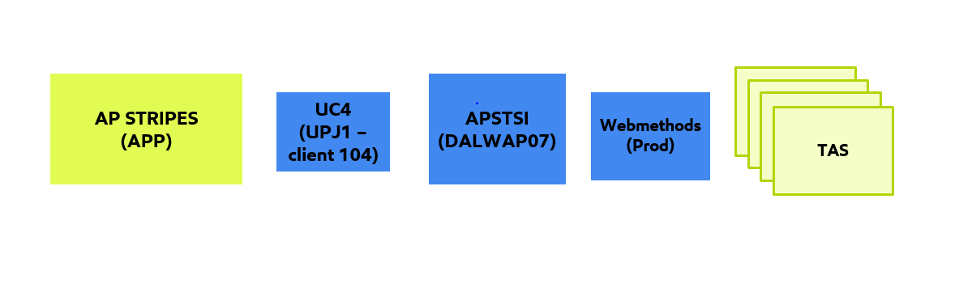
Fig-1: -Production environment

AP STRIPES which is our SAP connected to APP System, and we are using UC4 in between to run the jobs for extracting data or sending data between AP Stripes and APSTSI. In UC4 we are using client 104 and we are using WebMethods production in order to send data into TAS system.

- Acceptance Server
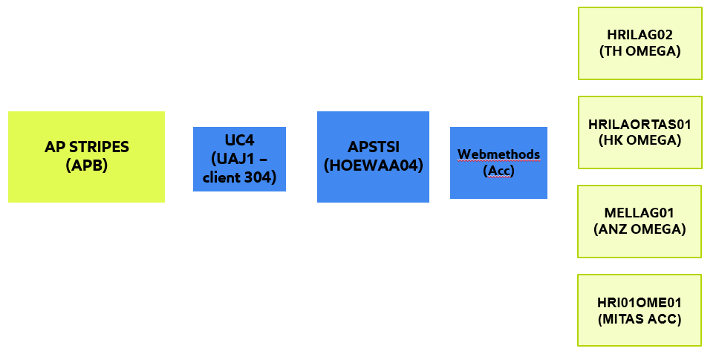
Fig-2: -Acceptance environment

For Acceptance server, we connected to Stripes again but it is in APB System, where UC4 will change client into 304 and we are using WebMethods that is in Acceptance server. And the TAS System we are using 4 environments HRILAG02(Using for Thailand Omega), HRILAORTAS01(Using for Hong Kong Omega), MELLAG01(Using for ANZ Omega), and these 3 servers are found on the TAS System but for MITAS System we are using another server called HRI01OME01.

- Development Server
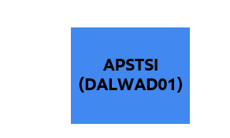
Fig-3: -Development environment

In Development, we can see that we did not connect to any system, so to make sure that we can play around completely in our system but not going to other application of the server.

Automation Engine (UC4): is an automation engine that is responsible for scheduling jobs and creating job plans to perform the validation activity on raw data received from SAP systems. It enables connectivity to multiple applications, databases etc. Automation engine interface provide the facility to create and check workflow steps. Every UC4 jobs internally calls the stored procedures to perform business logic operations within the job and It is also providing the information regarding which database, table and stored procedure, executable files are involved within the particular step of the job plan. UC4 is a powerful application job scheduling tool that enable us to define/crate workflow steps (validation, data preparation, copy, archive, cleanup, download, etc.)

OUTBOUND SEA-STRIPES to OMEGA5000:
Note: SEA STRIPES can also be referred as APSTRIPES or AsiaPacificSTRIPES. OMEGA5000 is one of the TAS System
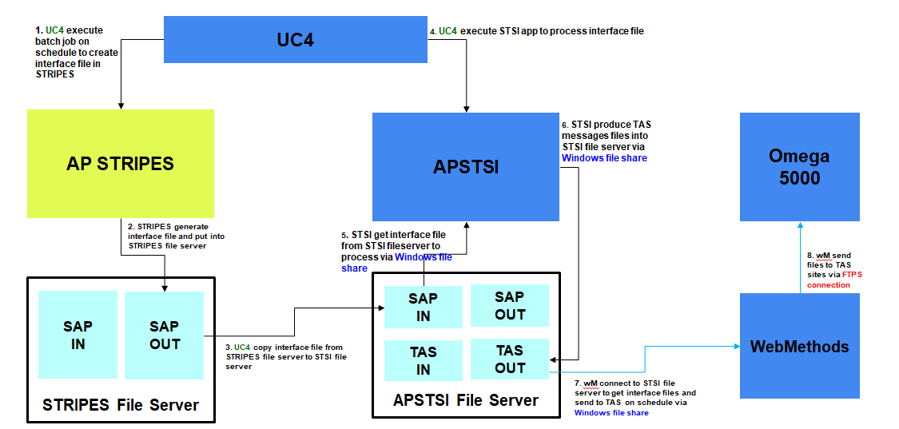
Fig-4: -Data flow diagram

The flow is from SAP to SAP File Server using UC4 to STSI File Server. We use WebMethods to communicate between TAS System and Omega5000 (not only Omega5000 and other TAS also). Outbound refers to data from SAP to outside world.
UC4 helps to create files in file server in SAP Side and UC4 will copy data from SAP file server to STSI File Server and STSI File Server will process data into STSI by using UC4 execution in order to receive data into STSI side. After that STSI will produce the TAS Message files into STSI file server ready to send to data to Omega or other TAS System. WebMethods come and pick the data from APSTSI File server and send to correct location according file name in that file.
Steps of processing of Outbound Data within the APSTSI Application:
Step 1: UC4 execute batch job on schedule to create interface file in STRIPES
Step 2: STRIPES generate interface file and put into STRIPES file server
Step 3: UC4 copy interface file from STRIPES file server to STSI file server
Step 4: UC4 execute STSI app to process interface file
Step 5: STSI get interface file from STSI fileserver to process via Windows file share
Step 6: STSI produce TAS messages files into STSI file server via Windows file share
Step 7: WebMethods connect to STSI file server to get interface files and send to TAS on schedule via Windows file share
Step 8: WebMethods send files to TAS sites via FTPS/SMTP/HTTPS connection.
INBOUND OMEGA 5000 to APSTRIPES
Let’s see about Inbound Transactions from TAS to Stripes:
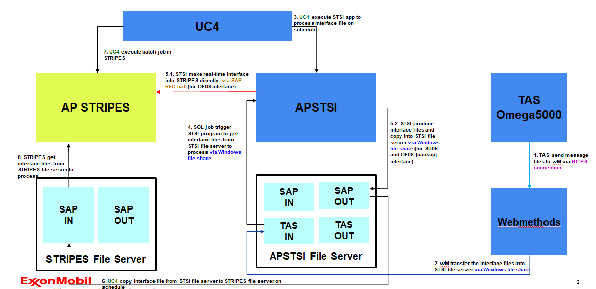
Fig-5: -Data flow diagram

TAS to send data with HTTPS Connection to WebMethods. WebMethods send data into APSTSI File Server. STSI have SQL jobs to trigger the program in order to process file in this folders into STSI. If file is already processed and everything validated, it will send data directly by using RFC Protocol, but if the connections with RFC protocols is done send the data into one of a table within STSI itself
And after UC4 can run and RFC is up, and UC4 will trigger STSI to produce file into file server and ready to send data by using BCP Protocol, After BCP already activated it will create a file to file server and send to Stripe File server and receive into Stripes by using UC4 activation.
Steps of processing of Inbound Data within the APSTSI Application:
Step 1: TAS send message files to WebMethods via HTTPS connection
Step 2: WebMethods transfer the interface files into STSI file server via Windows file share
Step 3: UC4 execute STSI app to process interface file on schedule
Step 4: SQL job trigger STSI program to get interface files from STSI file server to process via Windows file share
Step 5.1: STSI make real-time interface into STRIPES directly via SAP RFC call (for OF08 interface)
Step 5.2: STSI produce interface files and copy into STSI file server via Windows file share (for SU06 and OF08 [backup] interface)
Step 6: UC4 copy interface file from STSI file server to STRIPES file server on schedule
Step 7: UC4 execute batch job in STRIPES
Step 8: STRIPES get interface files from STRIPES file server to process
Tools and Technologies Used: SQL Server 2016, ASP Net (VB6) Automation Engine UC4, Web Methods, Visual Studio2015, Azure Devops, TFS, DTSX
Frontend Overview(User interface):

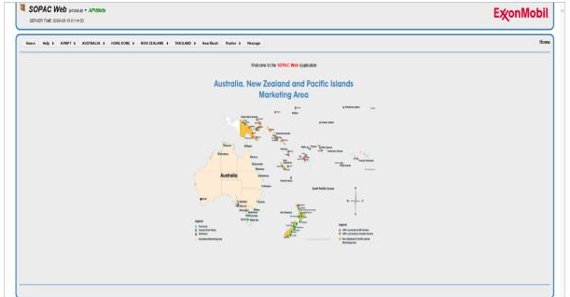
Fig-6: -AP STSI User Interface

This frontend design of APSTSI is very old; we are using this for time being until we move to OneSTSI completely in the future. NASTSI and APSTSI quite similar in the look and feel but the functionality is not exactly the same it is quite unique region. In APSTSI, we have split the front end and backend in the database all this by countries. We have Australia, Hong Kong, New Zealand, and Thailand and (since this is not the updated version of the slide) they have added one country Indonesia just began the support from last 2020.

Frontend – Report – Inbound data
- Show data that send from TAS to STSI (Business User Interface)
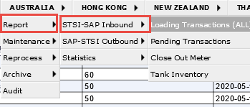
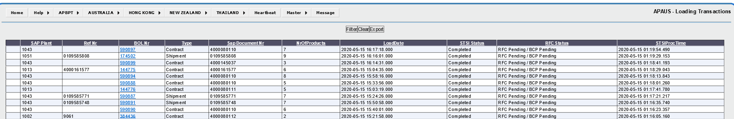
Fig-7: -Report User Interface (Inbound Data)

This is a Business user interface, on daily basis our Business users like Customer Service Team, PMI team and other teams, they would come here into their STSI whenever if they reported 40 transactions, some checks need to be done, just to get the data or to even monitor the correctness and interfaces and all. The basic functionality that the business user listed in this are:
If they go into the different countries, and then to the Report, we split the report between Inbound and Outbound. Now let’s see about Inbound, mostly they would look at the
Loading Transactions: Show already processed data (it can be validated data already sent to SAP Site)
Pending Transaction: Show data that already received but still not process in database (show all the data that received in STSI but not processed yet because some of the message type is missing, doesn’t contain transaction type and something like that). Shows transactions waiting to be completed like if they have not get the ordered data that we need to receive yet.
Close Out Meter: It is a PMI stuff, show Daily closeout detail that received into APSTSI
Tank Inventory-: Is also a PMI Stuff, show Daily tank inventory closeout detail that received into APSTSI
Frontend – Report – outbound data (Shows data sent from SAP to STSI to TAS System)
- Show APSTSI to TAS data
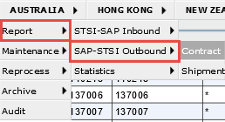
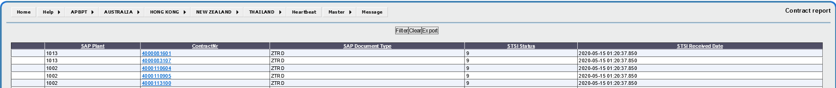
Fig-8: -Report User Interface (Outbound Data)

In this we show the Contract Data and Shipment Data from each country.

Frontend – Maintenance(Maintained by Business SME’s)
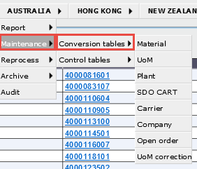
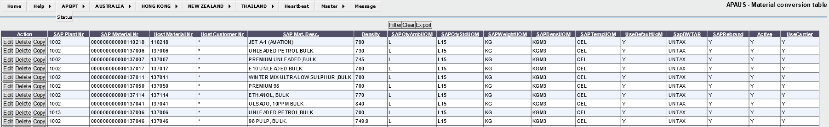
Fig-9: -Maintenance User Interface

- For showing and managing master data in APSTSI
- The business SME need to come and maintain these data by themselves in order to allow the terminal to send data into TAS properly
- Most of master data can be maintain by business SME. Not EMIT side.
Frontend – Reprocess(Managed by PMI and CS)
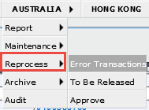
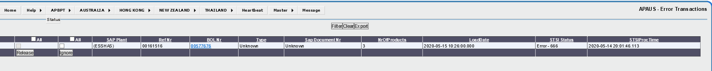
Fig-10: -Reprocess User Interface

STSI separates the Error cases. CS and PMI can just check it here Reprocess and Error Transactions. If TAS send data to STSI and have any issue, it will send to Error Transactions. PMI and CS have ability to come and correct or ignore data in Error transaction process page.
- If TAS send data to STSI and have any issue, it will send to Error Transactions
- PMI and CS have ability to come and correct or ignore data in Error transaction process page
Frontend – Archive
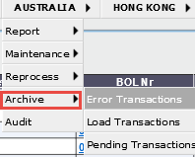
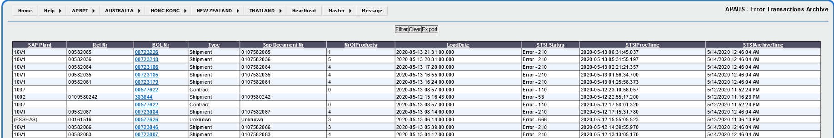
Fig-11: -Archive User Interface

This is mostly backend stuff, we have to ensure configuration.
  - Data will be archive every 3 months(Refer below fig-12 for the Archive Folder)
  - Data will be deleted from archive every 6 months
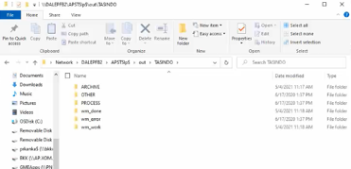
Fig-12: Path for Archive Folder
Frontend – Audit(Managed by Business users)
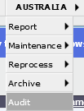
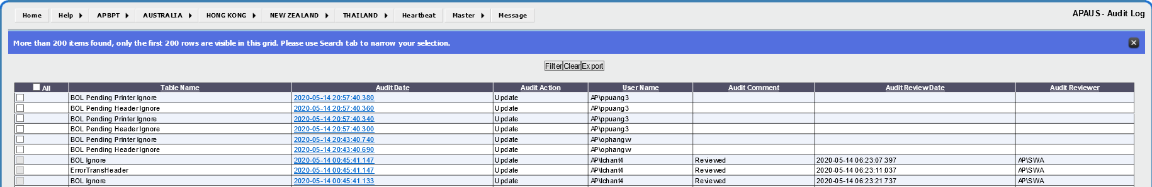
Fig-13: -Audit User Interface

- For every modification or ignore message in Error transaction, it will show in Audit page
- Business supervisor need to be reviewed these to be one of control report
Frontend – Heartbeat
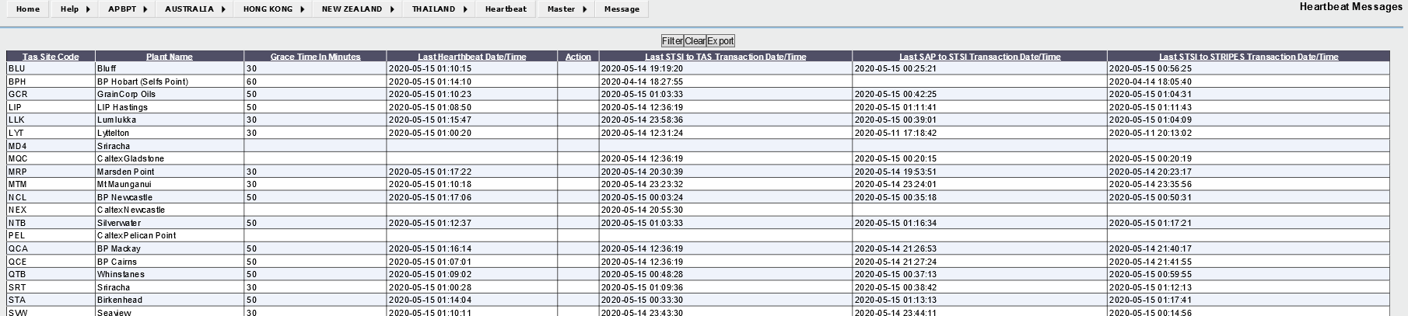
Fig-14: -Heartbeat User Interface

- Heartbeat is connection monitoring for TAS systems page (Monitors connection between TAS to STSI).
- If the terminal did not send any file with in the given time interval, we will get an alert “Investigate” to notify out team. For Example: Bluff we set it to receive data for every 30mins, if within 30mins Bluff could not save any file into STSI, we will alert to ensure the investigate data’s in STSI.
- If Action column in showing investigate, EMIT team need to investigate to solve the problem

Database in APSTSI:

We have lot of databases which are linked together by the functions and responsibility.
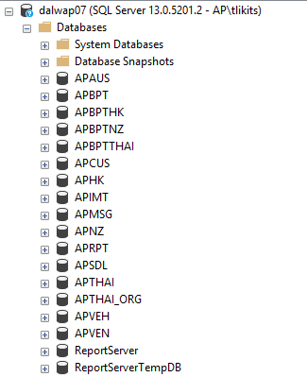
Fig-15: -APSTSI Database
- APSDL (Standard Data Load):
This Database is for receiving data into STSI either from SAP or TAS System. It contains programs to identify the data type and format before sending to next database.
- APBPT (Box Product Transaction Transfer):
This Database is used for managing transaction for each of the country. For sending data from STRPIES to TAS side, it uses APBPT in order to distinct the transaction and country before sending data to each country database. For sending data from TAS to STRIPES side, it uses for sending data back to STRIPES. It separated by country APBPT (APAUZ for Australia), APBPTNZ(New Zealand), APBPTTHAI(Thailand), and APBPTHK(Hong Kong).
- Country Database (APAUS, APNZ, APTHAI, APHK)
These databases are mainly used for processing data in each country. These databases contain the specific validation rule and message creation, depending on requirement in each country.
- APIMT (Interface Monitoring Tool)
This database is basically used for controlling interface setup in APSTSI application. For example, defining location of file path or control FIDN numbering
- APVEH (Vehicle Master)
  - It contains Vehicle master data that is required for truck validation
  - In Thailand interface, it has truck interface to TAS system via message set
  - In another country, it uses as for validating truck setup only
- APMSG (Message)
  - Store Logs of application, using for debugging and investigating
- APRPT (Report)
Data warehouse for Tableau
TAS -> SAP (Data sending from TAS to SAP System):

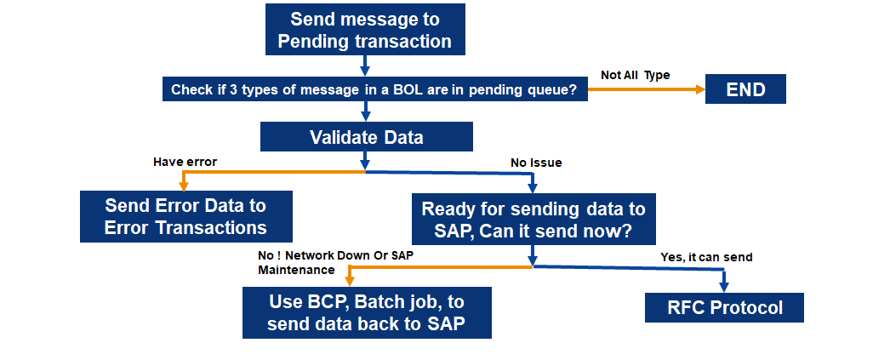
Fig-16: -Data flow from TAS to SAP
TAS sends data using Web Methods, WebMethods send data into STSI side by sending to Pending Transactions first, it will check whether data have all 3 types of message or not, if not it will go to end. If it already got 3 types of message of a transaction(Ref below Fig for 3 types of message), then it will validate the data. If it has any issue then it will send data to Error Transactions, but if not it will send data to SAP, either by using RFC Protocol or BCP Protocol.
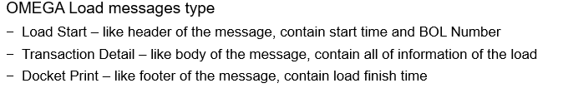
Fig-17: -Three types of message

